auto0Rocky Mountain Woodturners

A chapter of the American Association of Woodturners

December 2009 Newsletter

Contents of Newsletter

RMWT Meetings

Each month the Rocky Mountain Woodturners meet at Woodcraft of Loveland, located at 3718 Draft Horse Drive, Loveland, Colorado. We meet on the first Thursday after the first Tuesday of each month.

Meeting Format

6:00 – 6:15 – Setup and Social Time, come visit, share ideas and ask questions

6:15 – 6:45 – The general business meeting.  
6:45 – 7:05 Instant Gallery and Raffle

7:05 – 7:15 Break

7:15 – 8:45 – Demonstrator time.

8:45 – 9:00 – Clean up and out by 9 pm sharp!

Scheduled Meeting

The regular meeting for December, 3, 2009, will be a Christmas Party. Details to be announced.

**2009 Officers, Directors and Committees**

President: Drew Nichols

970-566-4662

[dcnichols2004@msn.com](mailto:dcnichols2004@msn.com)

VP: Katherine Kowalski

[katherine@daystarhandworks.com](mailto:katherine@daystarhandworks.com)

Phone: 307-637-2874

Treasurer: Pete Herman

Phone: (970) 663-1951, home

(585) 259-9486, mobile

Peter_herman@comcast.net

Secretary / Newsletter:

John Giem   
(970) 223-0844

<mailto:jgiem@comcast.net>

Newsletter Team

Editor: John Giem

970-223-0844

jgiem@comcast.net

Distribution:  
 Kevin Dunn

970-420-9691 Cell

dnnkk@msn.com  
Members:   
Pete Herman

RMWT Program Director:   
Trent Bosch

970.568.3299

[[trentbosch@yahoo.com](mailto:trentbosch@yahoo.com)](mailto:trentbosch@yahoo.com)

RMWT Librarian:   
David Amos

970.834.1432

[dcjeamos@juno.com](mailto:dcjeamos@juno.com)

Wood Bank   
Chairmen:

Allen Norris

Jerry Sherman

484-2619, home  
 631-2984, mobile

Wood Lot:   
John Giem,

223-0844, home  
 227-6618, mobile

**RMWT Symposium** Directors:   
Mike Davis -   
<mailto:mikeldavisllc@msn.com>  
Allen Jensen

970-663-1868

[Rajconst@aol.com](mailto:Rajconst@aol.com)  
Registration:  
John Giem  
970-223-0844  
<mailto:jgiem@comcast.net>

RMWT Webmaster   
 Hoyle Curtis

hoyle.curtis@gmail.com

Next RMWT Meeting, Christmas Party

RMWT Activities

RMWT Officer Elections

Treasure’s Report

EOG Announcement

Member’s web sites, sources of woodturning Instruction and discounts.

***Next RMWT Meeting***

 The Christmas meeting will be December 3rd at Mountain Range Shadow Clubhouse, 8401 Mummy Range Dr., Fort Collins, CO. Located on the west side of I-25 about 1 mile south of the Windsor exit. Should start around 6pm. Bring your favorite dish, soft drinks and plastic utensils will be provided. Bring a Christmas ornament to be auctioned to start the Rocky Mountain Woodturners funds for the new year. Also will have a great Instant Gallery, so bring something spectacular!  
Thanks,  
Drew Nichols, President Rocky Mountain Woodturners

**RMWT Activities**

*Election of RMWT Officers*

At the November 5, 2009, meeting of the RMWT, the election of Officers for 2010 was held. The following were elected:

President: Katherine Kowalski

Vice President: Dave Dowding

Secretary: Allen Norris

Treasurer: Pete Herman

In addition, Allen Norris will take over the position of Newsletter Editor.

*Treasurer’s Report*

|  |  |  |  |  |  |
| --- | --- | --- | --- | --- | --- |
| Beginning balance | |  |  |  | $4,172.17 |
|  |  |  |  |  |  |
| Income |  |  |  |  |  |
| Date | Source | Check/cash | Amount | Quantity | Extended |
| 11/13/09 | Membership | check | $40.00 | 1 | $40.00 |
|  | End sealer sale | check | $8.00 | 3 | $24.00 |
|  | End sealer sale | cash | $8.00 | 4 | $32.00 |
| 11/5/09 | Raffle proceeds | cash | $59.00 |  | $59.00 |
|  |  |  |  |  |  |
|  |  |  |  | Total income | $155.00 |
|  |  |  |  |  |  |
|  |  |  |  |  |  |
| Expenses |  |  |  |  |  |
| Date | Source | Check/cash | Amount | Quantity | Extended |
| 11/5/09 | Library DVDs | check | $85.50 | 1 | $85.50 |
| 11/5/09 | Monthly demo | check | $300.00 | 1 | $300.00 |
| 11/5/09 | Library DVDs | check | $65.00 | 1 | $65.00 |
| 11/23/09 | Symposium expense reimbursement | check | $88.52 | 1 | $88.52 |
|  |  |  |  |  |  |
|  |  |  |  | Total expense | $539.02 |
|  |  |  |  |  |  |
| Ending balance | |  |  |  | $3,788.15 |

*Educational Opportunity Grant*

The EOG Committee is now accepting applications for grants for this year. See the following documentation for information.

**Rocky Mountain Woodturners**

**Educational Opportunity Grant**

The purpose of this document is to describe the Rocky Mountain Woodturners Educational Opportunity Grant program. Rocky Mountain Woodturners is a chapter of the American Association of Woodturners (AAW), located in Loveland, Colorado. Please visit the Rocky Mountain Woodturners (RMWT) web site at [www.rmwt.org](http://www.rmwt.org), and the AAW web site at [www.woodturner.org](http://www.woodturner.org). The RMWT meets on the first Thursday after the first Tuesday of each month at 6:30 PM at the Woodcraft Store in Loveland, Colorado.

Applications for an Educational Opportunity Grant (EOG) from the RMWT are available each year. Applicants may apply by completing the attached application form and submitting it to Rocky Mountain Woodturners.The RMWT’s would like to assist you in your woodturning education. If you have a particular goal, workshop, or project in mind and desire financial help, we would like you to apply to this program.  
  
In order to expand and share woodturning resources, RMWT has established a fund from which grants are awarded to individuals and organizations. The grants will cover expenses such as tuition, registration, demonstrator's fees, travel, lodging, and meals.

**(1) Purpose of the Program**

* To allow RMWT members to benefit from their own fundraising efforts and generous support.
* To provide educational opportunities that expands and enriches the entire community.
* To provide ways that woodturning skills may be shared with RMWT members, seminars, schools, and friends.
* To allow persons outside the RMWT community to experience the benefits of woodturning.

**(2) Eligibility**

Applicants must be a member or sponsored by a member of the RMWT. Recipients must submit a report to the EOG committee chairperson on their experiences within three months of their completion.

**(3) Grant Committee**

RMWT shall establish a Grant Committee comprised of three members including a Chairperson and two others. The RMWT Board shall appoint the Chairperson. The Grant Committee Chairperson shall select two additional committee members. The Grant Committee serves at the pleasure of the RMWT Board. The board may change the committee chairperson at any time.

The Grant Committee shall perform the following duties:

1. Review applications for Educational Opportunity Grants

2. Inform the board of all EOG applications

3. Make recommendations to the board, including recommending which grants should be approved, and for what dollar amount. Three (3) Grant committee members shall vote with the Four (4) board members on grant requests. Applicants must gain five/sevenths support of the board & EOG committee in order to be approved.

4. Awards will be considered based on benefit to the applicant, to the community, to RMWT, and application concept,. Emphasis will be placed on the ability, as well as the opportunity, of an applicant to share information gained. Clarity of the application is essential, applications will be judged on the thought and the written ideas presented. Applicants will be judged on the content of the application alone.

5. The Grant Committee chairperson shall follow-up with recipients of EOGs to insure projects are completed on a timely basis, and that recipients present their results at a meeting of the RMWT, and provide a written report, which can be included in the RMWT newsletter and/or be posted on the RMWT web site.

6. The Grant Committee may recommend an EOG be awarded in unusual circumstances (relief, short-notice need, gift, etc.) without the submission of an application.

**(4) Submitting an Application**

All applicants must complete the Rocky Mountain Woodturners Educational Opportunity Grant Application Form and submit it to:

EOG Chairperson

Rocky Mountain Woodturners

**Rocky Mountain Woodturners**

**Educational Opportunity Grant**

**Application Form**

Please provide clear and concise answers to the following questions:

Name: __________________________________________________________

Date: _______________________________ Phone: _____________________

Address: ________________________________________________________

City, State, Zip Code: ______________________________________________

E-Mail Address: ___________________________________________________

Member or Sponsor name:___________________________________________

Age:_______ School affiliation:_____________________________________

1. How would you use the educational grant?

2. How would you benefit from the grant?

3. How would the community benefit from your grant?

4. Please give an itemized budget of how you intend to use the grant.

TIPS ON USING THIS FORM:

* Type, print or write legibly, your answers to the questions.

(If you download a copy from the RMWT website, you can download it in MSWord and type your answers right on the form, print and mail it to the RMWT.)

* Please do not submit CD’s or notebooks full of supporting data or photos. The grants are rated by the content of the answers to the questions. They are considered on their own merit.
* Please answer the questions in a clear and concise manner. Include additional sheets, if necessary.
* Please provide the name that will appear on any award check
* Budget: It is OK for your budget to exceed the award amount.
* Applicants may apply for a grant to:
  + Attend a symposium, workshop, or school.
  + Enable a special project.
  + Cover teaching expenses.
  + Any other reasonable cause

Submit 2009 completed applications to EOG Chairman John Harpold by e-mail to [jmharpold@skybeam.com](mailto:jmharpold@skybeam.com) or US mail to 6203 County Road 29C, Bellvue CO 80512. If you have questions regarding RMWT EOG grants, please contact John Harpold at the above addresses or by phone at (970) 482-0439, or anyone else on the EOG committee or RMWT Board.

The deadline for 2009 EOG grant applications is January 15, 2010

*Equipment for Sale*

Monty Weymouth has a Delta Milwaukee Lathe for sale. It has a 46" bed and 12" swing. He is including some turning tools and is asking $250.   He will be glad  
to help deliver it. Monty can be reached at 970 416-6590 or 970 222-8525.

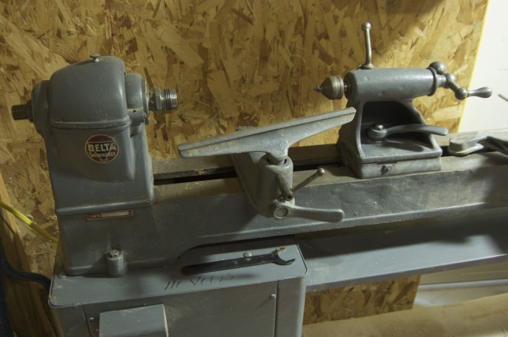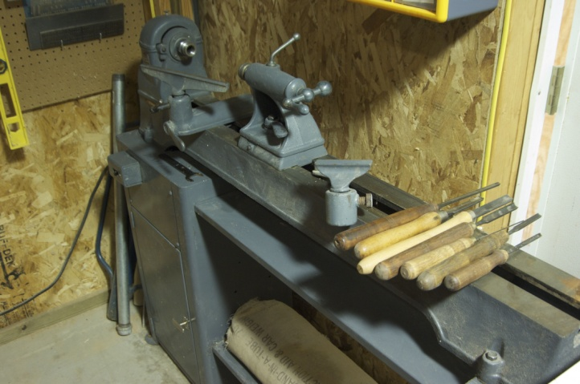

10% Guild discount

Wood Emporium

618 N Garfield Ave Loveland,

Sears Trostel

1500 Riverside Ave

Ft. Collins, CO 80524

Rockler’s in Denver – You have to show your membership card.

Woodcraft

3718 Draft Horse Drive  
Loveland, CO 80538  
970-292-5940  
Discounts on day of Club Meeting.

Clubs and Member’s Websites

Rocky Mountain Wood Turners

[www.rmwt.org](http://www.rmwt.org)

AAW – American Assoc of Woodturners

[www.woodturner.org](http://www.woodturner.org)

Trent Bosch

[www.trentbosch.com](http://www.trentbosch.com)

David Nittmann

[www.davidnittmann.com](http://www.davidnittmann.com)

Cindy Drozda

[www.cindydrozda.com](http://www.cindydrozda.com)

John Lynch

[www.johnlynchwoodworking.com](http://www.johnlynchwoodworking.com)

Curt Theobald

[www.curttheobald.com](http://www.curttheobald.com)

Katherine Kowalski  
<http://www.DaystarHandworks.com>

Want your Website Listed? Contact a member of the Newsletter Team!!!

**Learn From the Best…**

Our Club, RMWT, is known around the nation because we have some of the best turners, nationally known demonstrators and best teachers of Basic Turning, Intermediate, and Advanced and Specialty turning right here in our own back yard.

**Trent Bosch Woodturning Workshops**

Workshops are held in Trent’s studio in Fort Collins, Colorado. There is a maximum of four people in each class, which allows for lots of individualized instruction. The cost is $500 for the 3-day intensive workshop and $650 for the 4-day. Meals are also provided at no extra charge. His studio is also equipped with the highest quality equipment available for your use. For detailed information on workshops visit [www.trentbosch.com](http://www.trentbosch.com) or contact Trent via email or phone.

Trent Bosch

Trent Bosch Studios Inc.

trent@trentbosch.com

970 568 3299

­

**Lee Carter** operates the **Rocky Mountain School of** Woodturning in LaPorte, Colorado. He offers classes in Basics, Intermediate and Advanced. Lee also offers private tutoring. Seven different brands of lathes are available.

Call Lee Carter at 970-221-4382 to sign up or have him answer any questions.

e-mail [LLJTC4X4149@ CS.COM](mailto:LLJTC4X4149@%20CS.COM)

**Curt Theobald** offers three-day workshops in Segmented Woodturning in his studio in Pine Bluffs, Wyoming.

Call Curt Theobald at 307.245.3310

E-mail cwtheobald@wyoming.com

Website is [www.curttheobald.com](http://www.curttheobald.com)

**John Giem,**   Woodworker

Individual or small group woodworking instruction customized to the needs of the student. Offering both woodworking on the lathe and combined with regular power tools. Classes are held in John's workshop in Fort Collins, CO, which is equipped with a complete set of woodworking tools. Contact John to discuss your interests and needs.

[jgiem@comcast.net](mailto:jgiem@comcast.net)

(970)223-0844, home phone

(970)227-6618, cell phone

____________________________________________________________________________

### Woodcraft has classes for beginners in woodworking, shop safety, intro the machines, bowl turning, pen and pencil turning, hollow forms, Christmas tree ornaments, tool sharpening, etc.  Please check out the class being offered at web page

### [www.woodcraft.com/stores/store.aspx?id=56](http://www.woodcraft.com/stores/store.aspx?id=56)